**Lesson 04 Demo 01**

**Generating E-Commerce Architecture Application Using Generative AI**

**Objective:** To generate the microservice architecture of an e-commerce app using Generative AI for enhanced scalability and performance

**Tools required:** ChatGPT

**Prerequisites:** NA

Steps to be followed:

1. Generate architecture for the login page, add to the cart page, payment page, and purchase page using prompts

**Step 1: Generate architecture for the login page, add to the cart page,   
 payment page, and purchase page using prompts**

* 1. Open the browser and write the below URL as

<https://chatgpt.com/>

* 1. Provide the following prompt to generate descriptions of the secure login page for the e-commerce platform:

**Design the architecture for a secure Login Page in an E-commerce platform. Consider user authentication and account management services.**

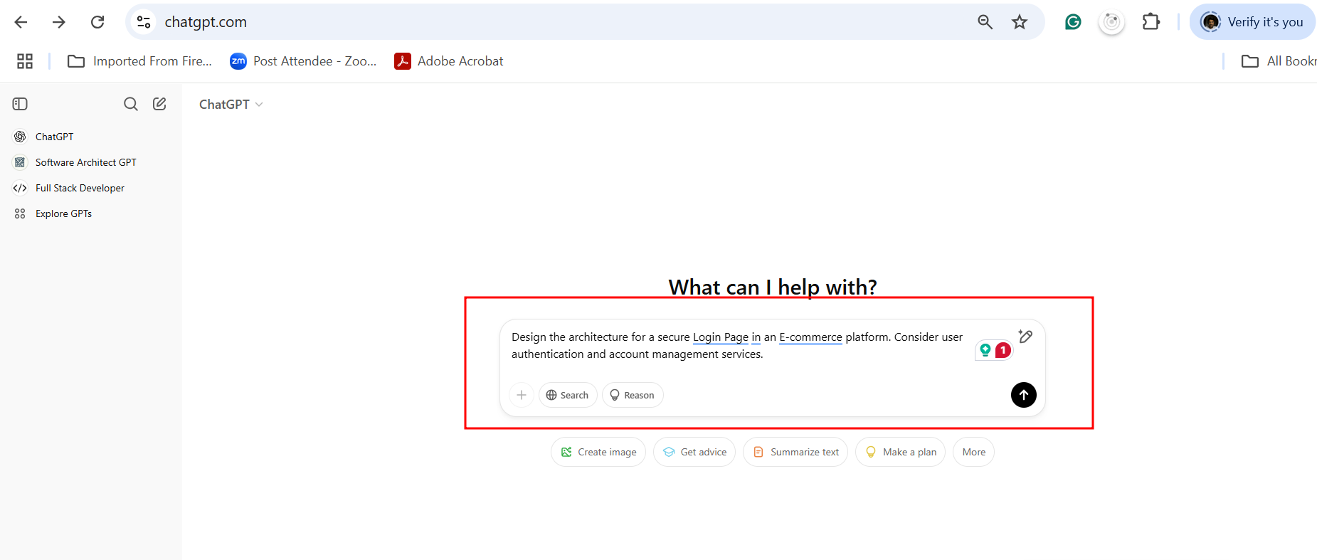

So here you can see the below output. Which will give the idea about frontend, backend and database with micro service architecture style

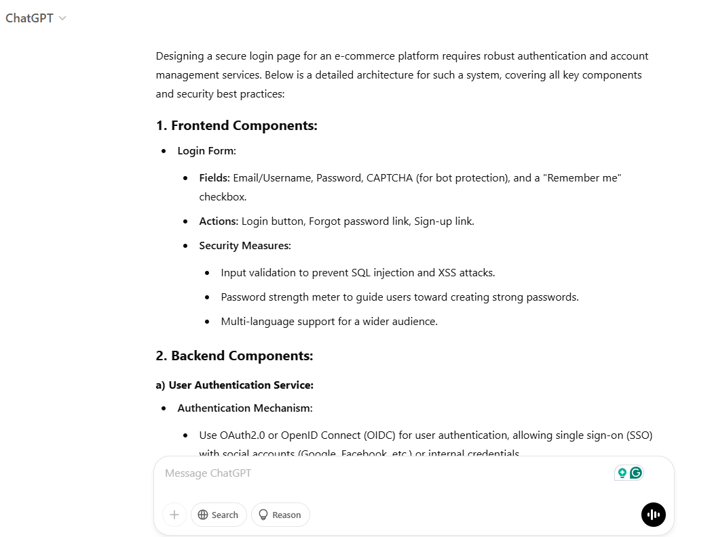

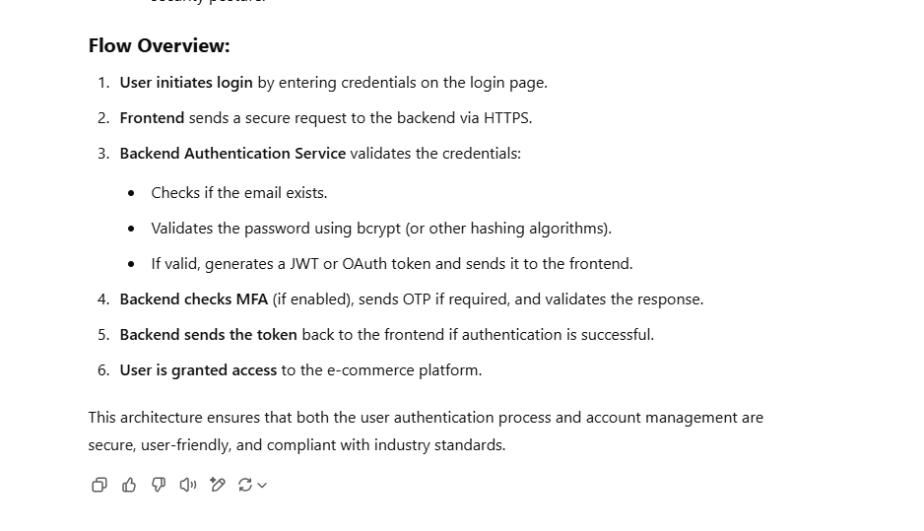

The output can be different based upon the prompt question.

* 1. Generate an ASCII art diagram for the login page using the following prompt:

**Provide an ASCII art diagram illustrating the Login Page architecture.**

**Note:** ASCII stands for American Standard Code for Information Interchange.

The GPT generates the following ASCII art diagram:

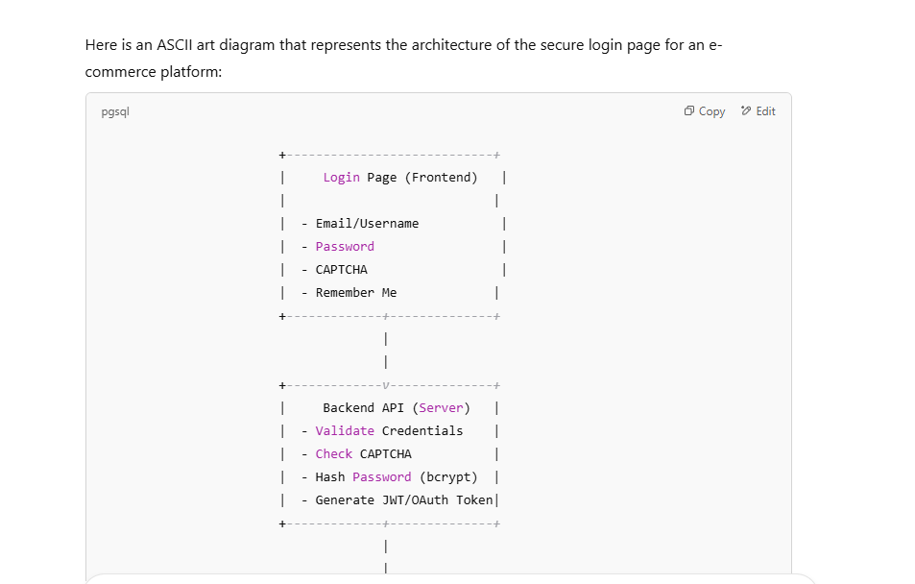

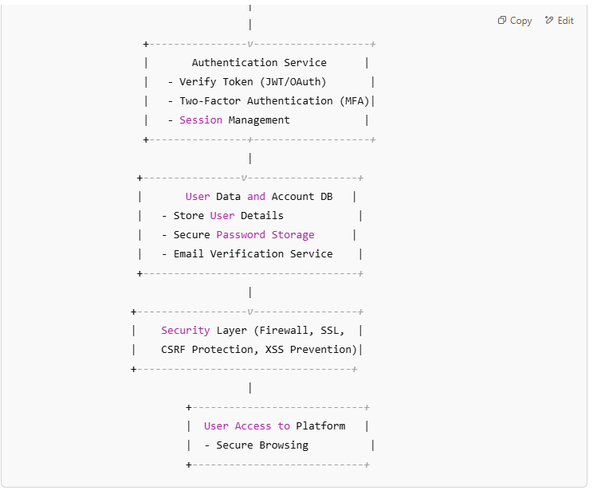

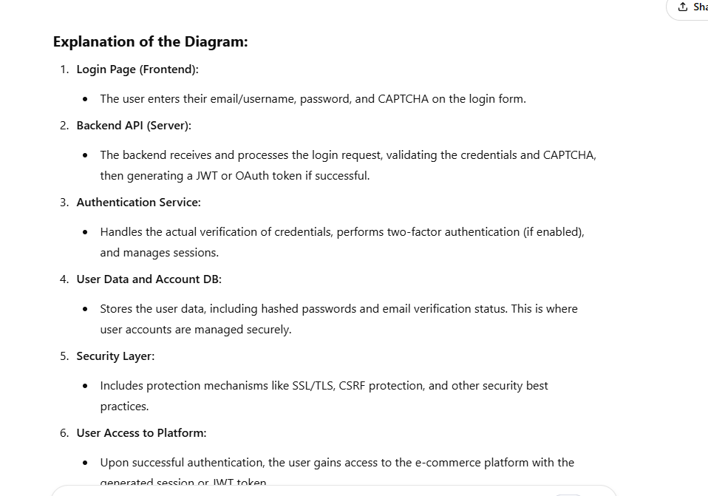

* 1. Use the following prompt to generate the requirements for an **Add to Cart** page:

**Architect the "Add to Cart" Page for a retail website. Ensure seamless integration between the client-side interface and backend services.**

It generates detailed information for building the page.

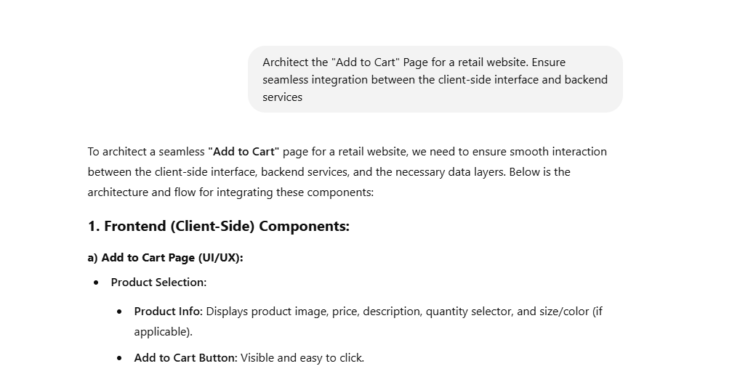

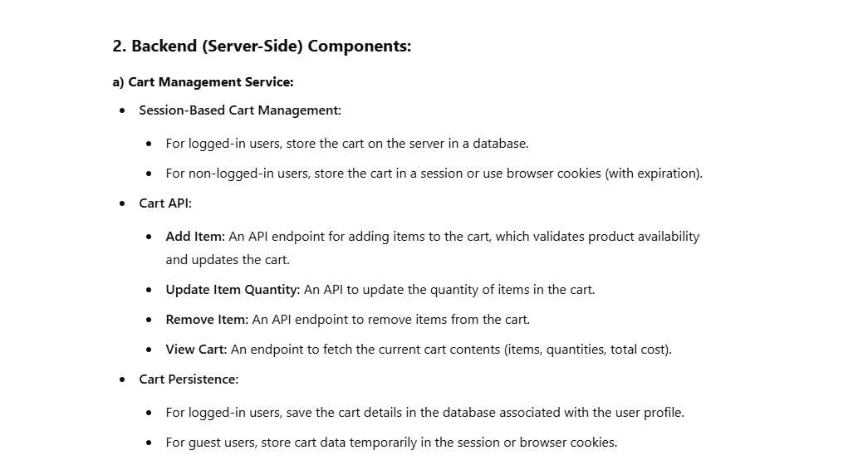

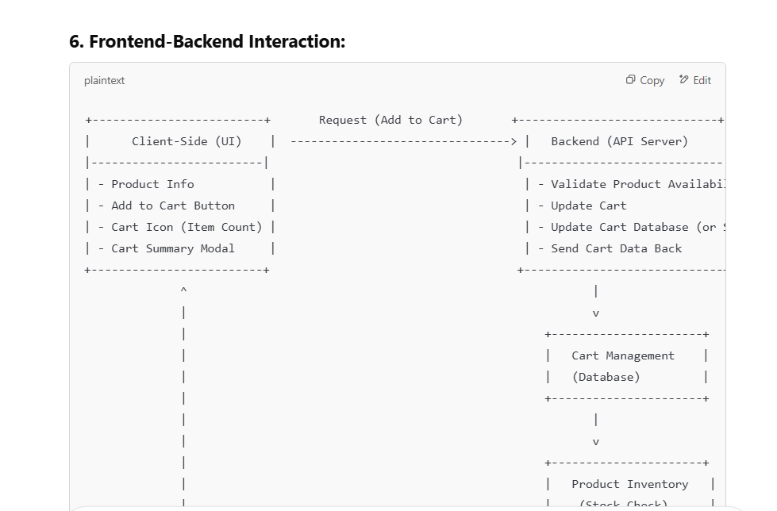

* 1. Use the following prompt to generate descriptions and requirements for designing the payment page:

**Design the Payment Page for a subscription-based service. Prioritize security and compliance in payment processing.**

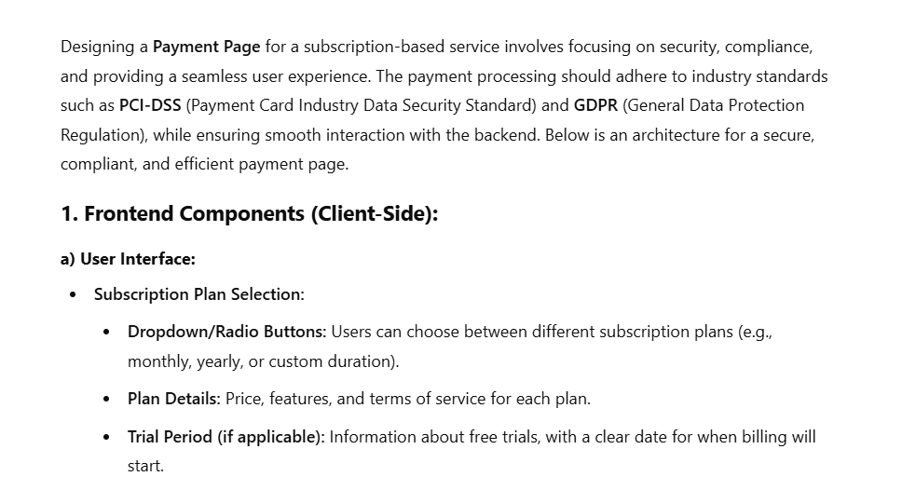

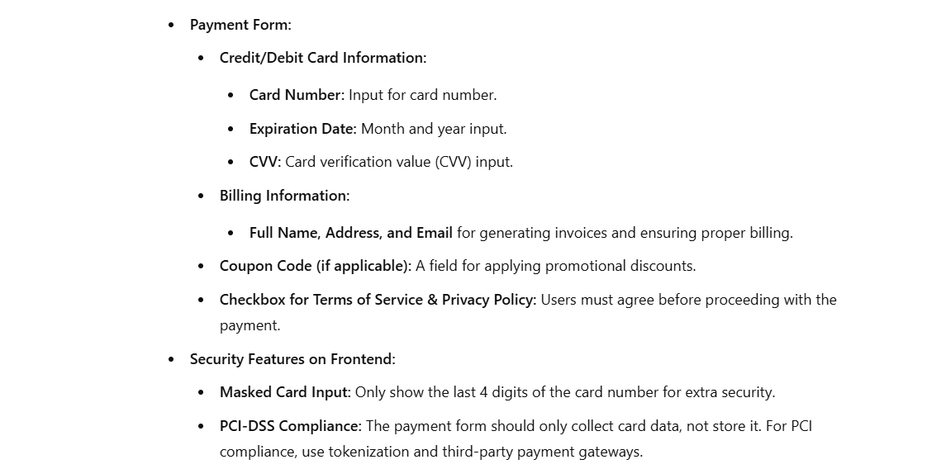

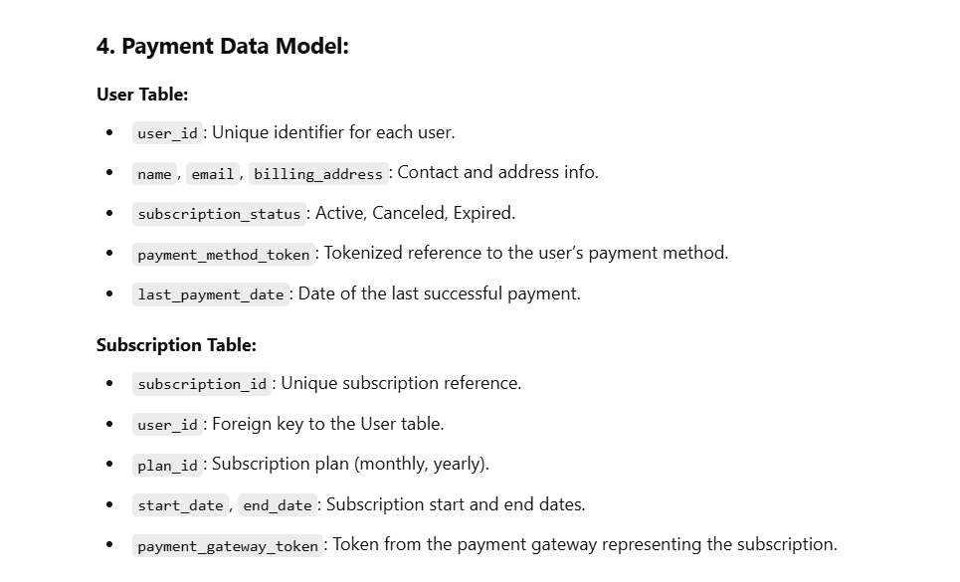

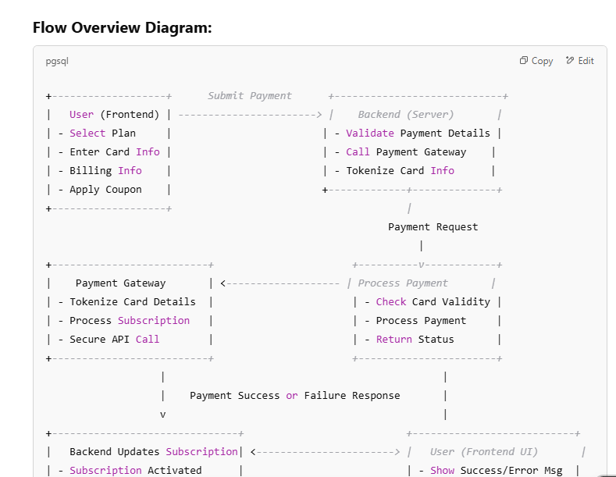

* 1. Generate a purchase page for the travel booking platform using the following prompt:

**Architect the Purchase Page for a travel booking platform. Ensure smooth handling of transactions and real-time updates.**

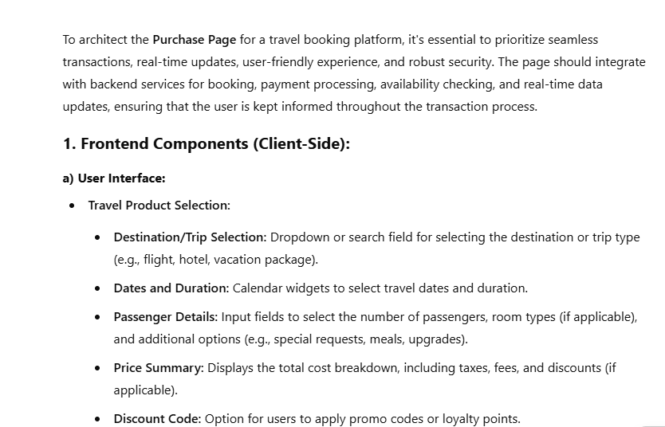

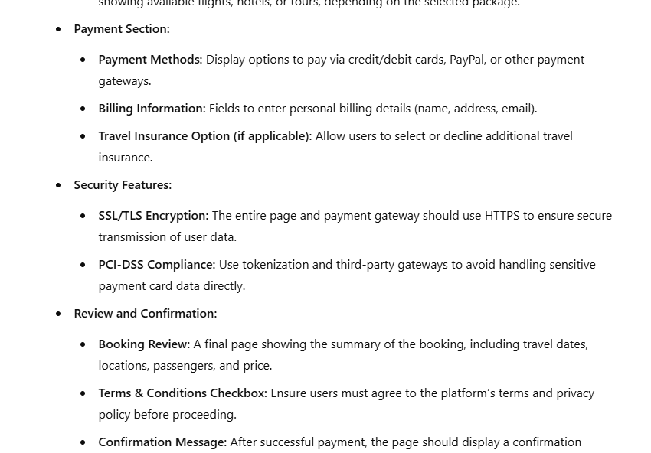

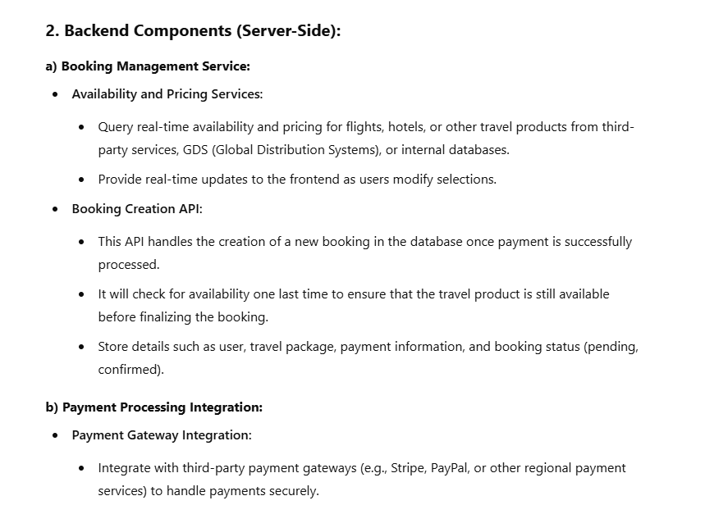

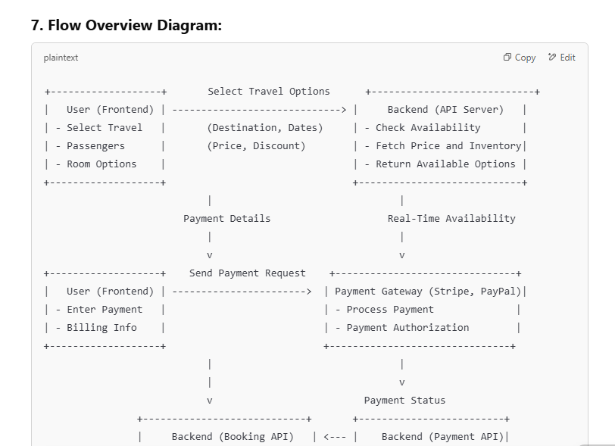

**Note:** The output can be different based upon prompt message as well as GPT model.